**DATABASE ASSIGNMENT**

Q1) What do you understand by Database.

Ans : Collection of many types of data, in a single place is the database, where we can store and access any data from different commands.

Q2) Normalization :

Ans : When we collect and store the whole data into smaller units or data in simple ways or making smaller tables for a whole table is normalization.

Q3) Difference between RDBMS and DBMS.

Ans : RDBMS : if we collect the data in tabular format like in SQL

DBMS : if we collect the data in file format like xml

Q4) MF cod rule of RDBMS.

Ans : Database Management System or DBMS essentially is used to access, manage and update the data. Which helps easy to retrieve and store the information into the database.

Rules to maintain :

* Data Modelling − It is all about defining the structures for information storage.
* Provision of Mechanisms − To manipulate processed data and modify file and system structures, it is important to provide query processing mechanisms.
* Crash Recovery and Security − To avoid any discrepancies and ensure that the data is secure, crash recovery and security mechanisms are must.
* Concurrency Control − If the system is shared by multiple users, concurrency control is the need of the hour.

Q5) Data Redundancy.

Ans : In this we maintain the single data into different data tables, generally it’s not considered good, because the delay time in retrieving of the single data.

Q6) DDL Interpreter.

Ans : Data Defination Language interpreter generally consists of commands like create or delete on database and tables.

Q7) DML Compiler.

Ans : Select, Insert, Update, Delete are used in mysql in Data manipulation Language in the mysql.

Q8) Key constraint.

Ans : keys are specified functions for the variables.

Like : PRIMARY, UNIQUE

Q9) Save Point.

Ans : In this we use Rollback command to retrieve the table after using delete commands.

Q10) Trigger.

Ans : use to make special functions which runs automatically when we write a command.

CREATE TRIGGER update_pass

BEFORE UPDATE ON users_tbl_new

FOR EACH ROW INSERT INTO user_pass_backup

SET user_id=OLD.userid, password=OLD.password, data=now()

QUES 1)

Table student :

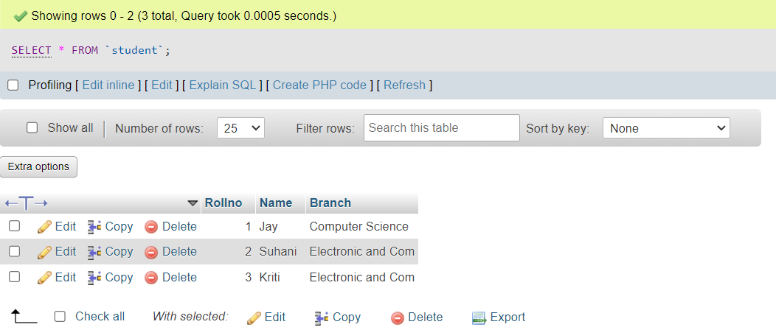

Table Exam :

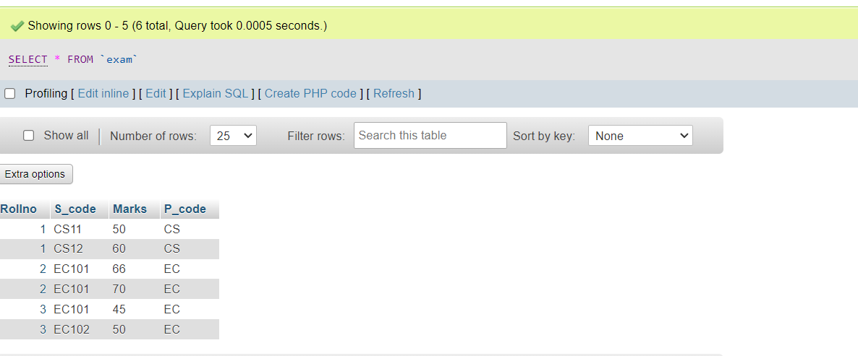

QUES 2)

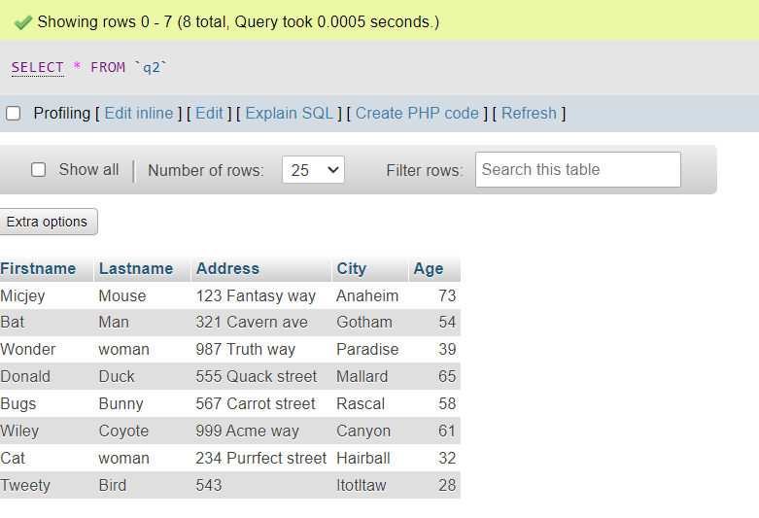

QUES3 )

a :

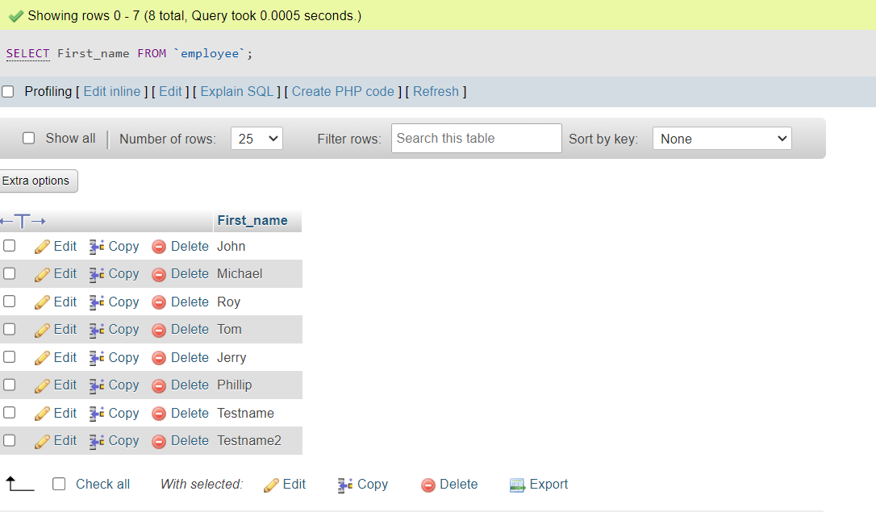

B :

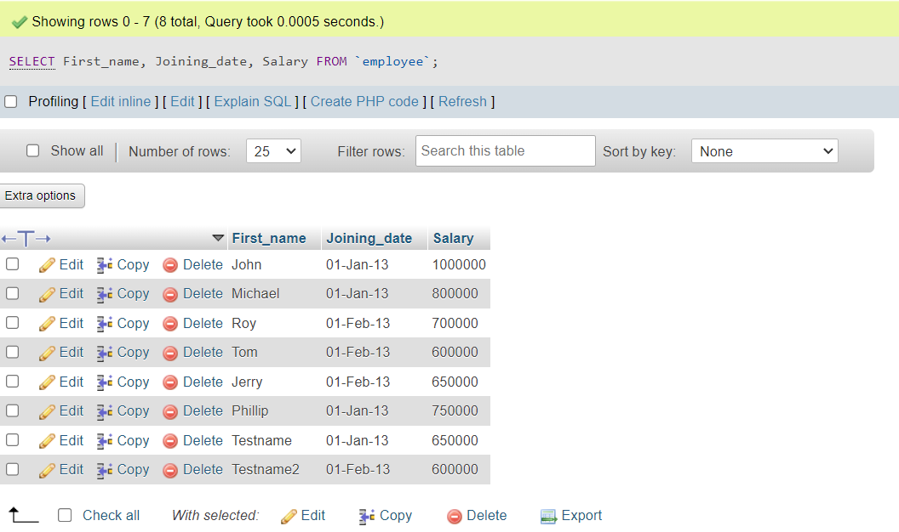

C :

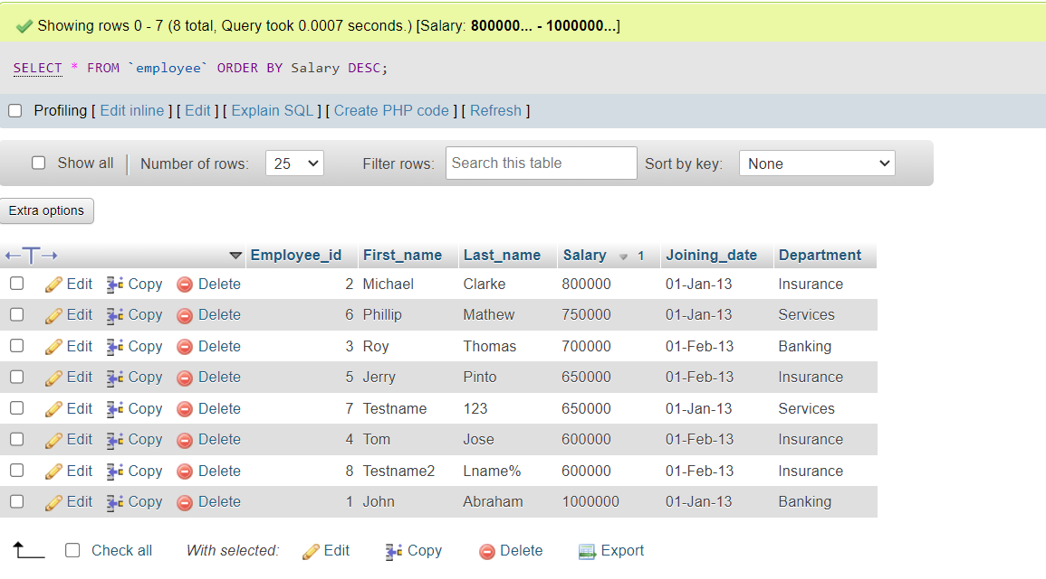

D :

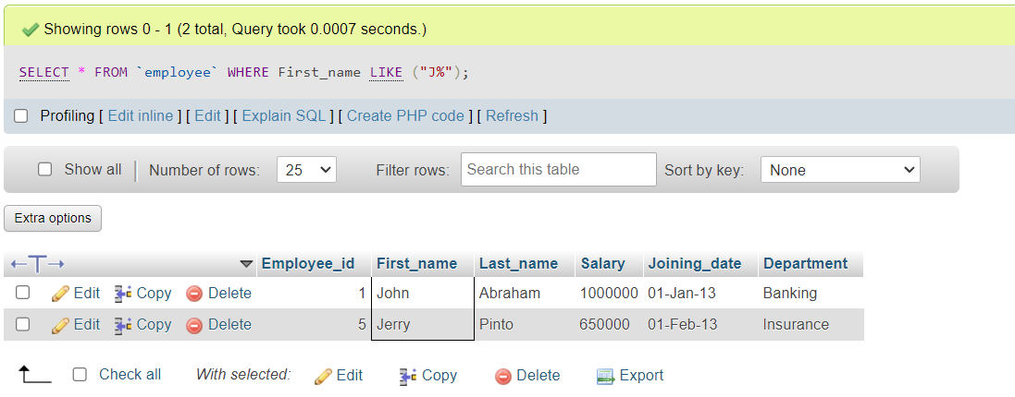

E :

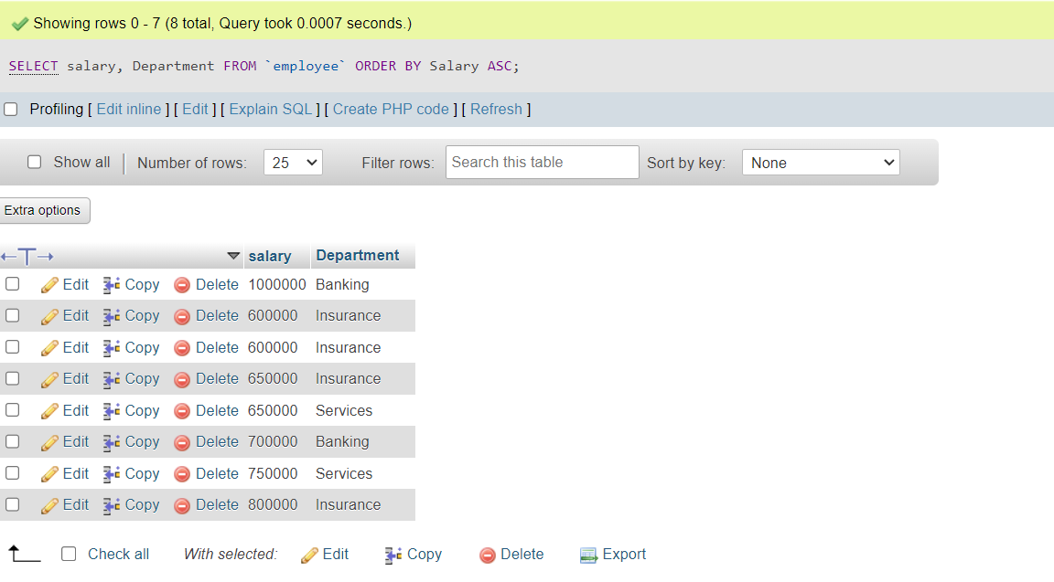

F:

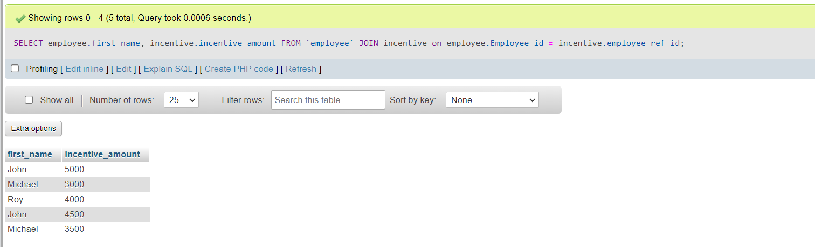

G:

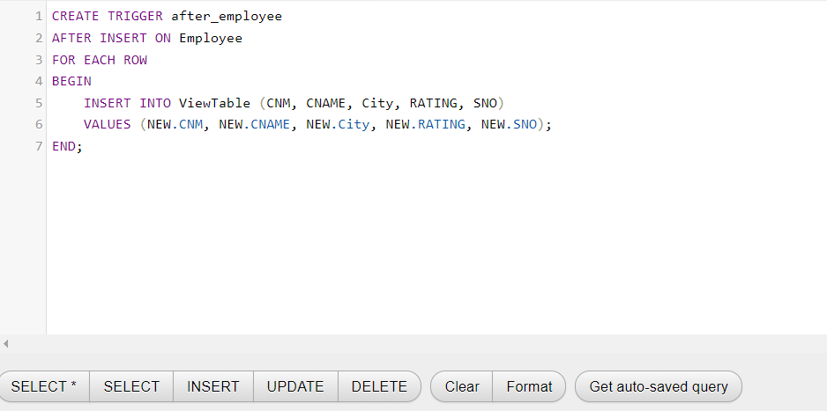

QUESTION 4)

A :

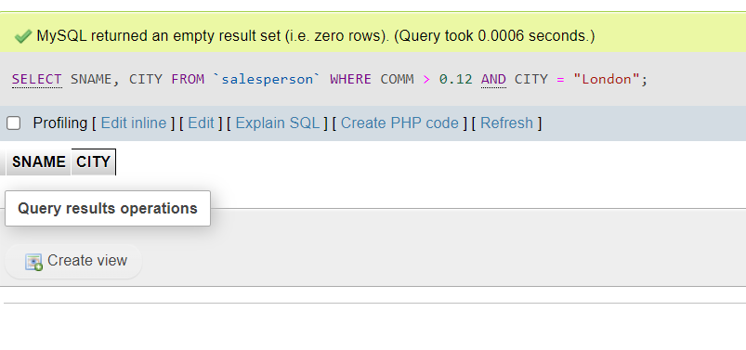

B :

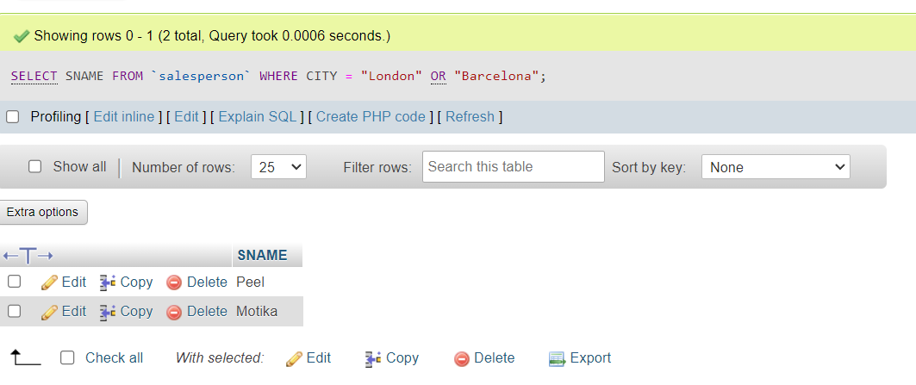

C :

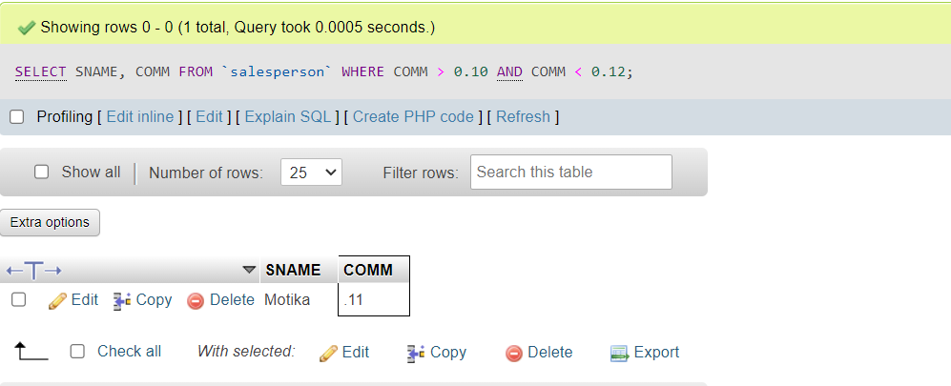

D :

